**1.0 INTRODUCTION**

**1.1 Background of the Industrial Training**

The industrial training is the training programme which forms part of the academicstandards in the various degree programs for all Nigeria Tertiary Institutions. It seeks to bridge the gap existing between technology and other professional education programs in Nigerian Tertiary Institutions.

1.2 **[Students Industrial Work Experience Scheme (Siwes)](http://leavestoryng.blogspot.com/2015/12/history-of-siwes-student-industrial.html)**

In the earlier stage of science and technology education in Nigeria, students were graduating from their respective institution without any technical knowledge or working experience. It was in this view that students undergoing science and technology related courses were mandated to undergo industrial training in the view of widening their horizons so as to enable them have technical knowledge or working experience before graduating from their various institutions. The Student Industrial Work Experience Scheme (SIWES) was established by the Industrial Training Found (ITF) in 1973 to enable students of tertiary institutions have basic technical knowledge of industrial works base on their courses of study before the completion of their program in their respective institutions. The scheme was designed to expose the students to industrial environment and enable them develop occupational competencies so that they can readily contribute their quota to national economy and technological development after graduation. The major background behind the embankment of students in SIWES was to expose them to the industrial environment and enable them develop occupational competencies so that they can readily contribute their quota to national economy and technological development after graduation. The major benefit to students who participate conscientiously in SIWES are skills and competencies they acquire. The relevant production skills remain a part of the recipient of industrial training as life-long assets which cannot be taken away from them. This is because the knowledge and skills acquired through training are internalized and become relevant when required to perform jobs or functions.

**1.3 Vision of SIWES**

The vision of SIWES is to prepare students to contribute to the productivity of their nation. Also is a skill training and competence building intervention for students of tertiary institutions to have the potentials of increasing the scope and variety of technical skills in the common pool or general stock available for the industrial development of Nigeria

**1.4 Mission of SIWES**

Mission of SIWES is tocharged with responsibility of students that are expected to develop occupational competence that would facilitate their fitting into the world of work after graduation. The programmes of SIWES are designed to achieve the following objectives: Provision of avenue for students to acquire industrial skills and experience during their course of study.

1.5 **Aim and Objective of SIWES**

* To provide an avenue for students in the Nigerian Universities to acquire industrial skills and experience in their course of study. The objective of SIWESare:
* To prepare students for the work situation they are likely to meet after graduation.
* To expose students to work methods and techniques in handling equipment and machinery that may not be available in the Universities.
* To opportunity for students to blend theoretical knowledge acquired in the classroom with practical hands-on application of knowledge required to perform work in industry.
* To exposure of students to the environment in which they will eventually work, thereby enabling them to see how their future professions are organized in practice.
* To preparing students for employment and making the transition from school to the world of work easier after graduation.
* To enhancing students’ contacts with potential employers while on training.

1.6.**Definition of Terms**

* **Audio Mixer:**Is electronic device that receives two more input sound signals and afford one output at a time. It used for changing the quality and the levels of audio signals.
* **Vision Mixer:**Is electronic device that receives two more input vision signals and afford one output at a time. It also used to select between several different video sources and in some cases compositing (mix) video sources together to create special effects.
* **Signal:**Is the special data that is used to set up control communication, either analogue or digital.
* **Distribution Amplifier (Also Known As A Distribution Amp Or Da):**Takesa video signal as an input, amplifies it, and outputs the amplified video signal to two or more outputs. It is primarily used to supply a single video signal to multiple pieces of video equipment.
* **Transmitter:** Is the device that takes information and converts it into a signal are called the transmitter egbroadcasting tower.
* **Electronic Components:** These are the devices or different elements that made up of the circuit.
* **Circuit:** In electronics a circuit is a path between two or more points along which an electric current can flow. In telecommunication, a circuit is a discrete (specific) path between two or more points along which signal can be carried.

**2.0 OVER VIEW OF THE ORGANIZATION**

2.1 **Brief History of Katsina State Television Station**

Katsina State television service (KTTV) was established in 1988 under the Katsina Broadcasting Corporation (KTBC). The station got its autonomy in 1991 when a general Manager was appointed to oversee the running of the station. The state television had two sub stations, these are; the Katsina state metropolitan station which is serving as headquarters located along Batsari road, Katsina and Dabawa station located at Dabawa. KTTV was later merged with Katsina State Radio and become Katsina state Radio and Television service (KTRTV) for the second time in 1999 (Kabir, 2017).

Under the able leadership of Late President then the Executive Governor of Katsina State AlhajiUmaru Musa Yar'adua and the former Governor, His Excellency Barr. Ibrahim ShehuShema the station got a deliberate infrastructural development. The state Government acquired and installed booster station located at Daura (80Km from Katsina) to cover the Eastern parts of the state, Funtua (200Km from Katsina) to cover the Southern parts of the state and Dabawa (64Km from Katsina) to cover the central parts of the state. With the new technology trend of modern broadcast media, the central room as well as studios was overhauled replacing the analogue with digital system. The entire organization is now fully computerized. The station was operating with purely analogue transmitter and analogue gadgets in the studio and editing room, later the station transformed to a solid state transmitter with semi digital gadgets installed in the control room and editing room.

But in 2016, under the leadership of Rt. HonourableAminu Bello Masari the state Executive Governor, the station recorded tremendous changes where the station started operating on dual (digital analogue) transmitter with full digital gadgets in the control room and editing room. With these new technological developments, the station's studio is full with purely digital equipment ranging from digital cameras, video mixer and audio mixer machines together with other

accessories in the studio. Likewise, the editing room has digital editing suite which is providing a networking system to the saver in the main control room. This is unlike before where copy of the material was carried on hard copy to control room for transmission but because of the networking it is now sent on soft copy to the saver in the control room where the edited programmes can be retrieved on the time line for transmission. In addition, the station has constant power supply with the new high grade standby generators at the Headquarters in Katsina and booster stations at Dabawa, Daura and Funtua, a situation which enable the output of the station improved tremendously (Kabir, 2017).

Today, the station enjoys wider coverage, high quality reception and our signals are being received clearly in some parts of Kaduna, Kano, Jigawa and Zamfara states as well as some parts of Niger Republic. This encouraging development has invariably translated to higher rating of the station by the independent media monitoring service. We were rated fifth out of about twenty television stations in the North - West zone.

**2.2 Objective of Katsina State Television**

* Educate People:e.g,Programme of IlimiJari that guide people to maintain traditional business
* Enlightenment:e.g,Programme of TaskarKatsina that makes clear to activities of Government.
* Entertainment:e.g, Programme ofCiki Da gaskiya and sports News To be a state television station for the broadcasting of daily news on events happening in Katsina State and Nigeria at large.

**2.3 Departments/units of KTTV and their Duties**

The management of the corporation is made up of a Chief Executive/General Manager along with four (4) Heads of Departments

## Program Service Department

The program department acquires and schedules the programs that the audience will consume. It is the responsibility of the department to set time for which the programs of the station will start and end. It also arrange the programs in their order and broadcasting time.

## News and Current Affairs Department

The news department is responsible for creating news program such as news cast and news interview shows. Members of the news team will participate in the production of public affairs program. It is the responsible of this department to copy, review and edit the stories and videos before broadcasting.

## Administration and Supplies Department

The administration operations manage and distribute the revenue received from the station commercial department. This includes the appropriation of the available funds to each department as well as the billing of supplies and services to the departments.

## Finance and Accounts Department

Finance and account department of the station play an important role in the management of the station. Their responsibilities include financial planning, sourcing funds, financial auditing, financial records etc.

**2.4 Organogram of KTTV**

General Manager

Director Commercial Services

Director Finance and Accounts

Director Admin and Suppliers

Director News and Current Affairs

Director Engineering services

Director program services

**3.0 ACTIVITIES/EXPERIENCE ACQUIRED**

**3.1 Preamble**

The department of physics, Federal University Dutsin-ma posted the students for students industrial work experience (SIWES) to different organizations in the country. Likewise, I was postedto KatsinaState Television Katsina on 1thjuly, 2019 as a SIWES student to participate for a period of six KTTV months. Hence, the station received me and posted me to engineering department where I could obtain the necessary skills and experience with regard to my course of study.Moreover, I completed the placement on the 3rdof December, 2019.

**3.2 Activities during the training**

During my SIWES in KTTVKatsina, I have been posted to different places for me to gather the experience considering to my course of study. The four places which I have been posted include:

* + 1. **Control Room:** This is operations center where physical facility or physically isolated devices can be monitored and controlled. In the control room I was introduced to some of the equipment and devices, their functions and uses;

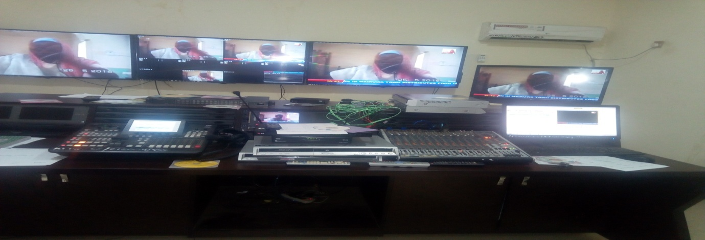

Plate1: Control Room

Common devices found in control room include:

1. Audio mixer
2. Vision mixer
3. HDD
4. Distributional amplifier
5. Camera control Unit
6. Un-interrupted Power Supply
7. CPU/Monitor
8. **Audio mixer:**

Thisis electronic device that receives two more input sound signals and afford one output at a time.It is used for changing the quality and the levels of audio signals. It is also known as a mixing console, an audio mixer, or a soundboard. Furthermore, I participated in KTTVKatsina Local news using the audio mixer.

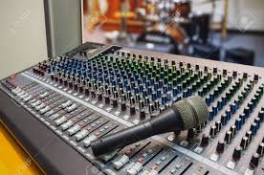

Plate 2: Audiomixer

1. **Vision mixer**

Vision mixer:Is an electronic device that receives two more input vision signaland afford one output at a time. It also used to select between several different video sources and in some cases compositing (mix) video sources together to create special effects. This is similar to what a mixing console does for audio. Likewise, I participated in KTTV local news where I operated Vision mixer.

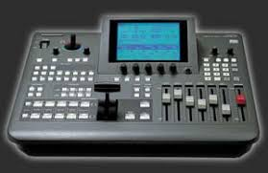

Plate 3: Vision mixer

**C**. Hard Disk Drive (HDD)

A hard disk drive (HDD), hard disk, hard drive, or fixed disk, is an electromechanical [data storage device](https://en.wikipedia.org/wiki/Data_storage_device" \o "Data storage device) that uses [magnetic storage](https://en.wikipedia.org/wiki/Magnetic_media" \o "Magnetic media) to store and retrieve [digital](https://en.wikipedia.org/wiki/Digital_data" \o "Digital data) information using one or more rigid rapidly rotating disks ([platters](https://en.wikipedia.org/wiki/Hard_disk_platter" \o "Hard disk platter)) coated with magnetic material. The platters are paired with [magnetic heads](https://en.wikipedia.org/wiki/Disk_read-and-write_head" \o "Disk read-and-write head), usually arranged on a moving [actuator](https://en.wikipedia.org/wiki/Actuator" \o "Actuator) arm, which read and write data to the platter surfaces. Data is accessed in a [random-access](https://en.wikipedia.org/wiki/Random-access" \o "Random-access) manner, meaning that individual [blocks](https://en.wikipedia.org/wiki/Block_%28data_storage%29" \o "Block (data storage)) of data can be stored or retrieved in any order and not only [sequentially](https://en.wikipedia.org/wiki/Sequential_access" \o "Sequential access). HDDs are a type of [non-volatile storage](https://en.wikipedia.org/wiki/Non-volatile_storage" \o "Non-volatile storage), retaining stored data even when powered off.



Plate 4: Hard Disk Drive

1. **Distributional amplifier**

Distributional Amplifier (also known as a distribution amp or DA) takes a video signal as an input, amplifies it, and outputs the amplified video signal to two or more outputs. It is primarily used to supply a single video signal to multiple pieces of video equipment. It adjusts the [amplitude](https://en.wikipedia.org/wiki/Amplitude" \o "Amplitude) of a video signal to compensate for loss of signal in a video distribution system. Extending the distance of the video signal is the main purpose of the VDA. There are VDAs built for all video formats, [NTSC](https://en.wikipedia.org/wiki/NTSC" \o "NTSC), [ATSC](https://en.wikipedia.org/wiki/ATSC" \o "ATSC), QAM16, QAM32, QAM64, [Composite Video](https://en.wikipedia.org/wiki/Composite_Video" \o "Composite Video) and [Component Video](https://en.wikipedia.org/wiki/Component_Video" \o "Component Video).

Their construction and capabilities can be simple; accept input signal, amplify, then output. Others can be more sophisticated that allow remote control from a control station, allow adjustment of the gain, equalization, and provide status of the input and output signals through Ethernet networks.

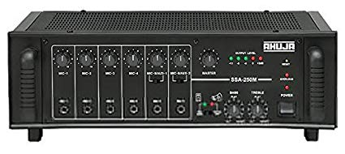

Plate5: Distributional Amplifies

1. **Camera control Unit**

The camera control unit (CCU) is typically part of a [live television](https://en.wikipedia.org/wiki/Live_television" \o "Live television) broadcast chain. It is responsible for powering the [professional video camera](https://en.wikipedia.org/wiki/Professional_video_camera" \o "Professional video camera), handling signals sent over the camera cable to and from the camera, and can be used to control various camera parameters remotely.

A CCU is often used in conjunction with a remote control panel (RCP), a [waveform monitor](https://en.wikipedia.org/wiki/Waveform_monitor" \o "Waveform monitor) and [vectors cope](https://en.wikipedia.org/wiki/Vectorscope" \o "Vectorscope) to rack and match many cameras together remotely.

Common adjustable parameters include:

* Iris (see [aperture](https://en.wikipedia.org/wiki/Aperture" \o "Aperture))
* [Color temperature](https://en.wikipedia.org/wiki/Color_temperature" \o "Color temperature) filters
* [Neutral density filter](https://en.wikipedia.org/wiki/Neutral_density_filter" \o "Neutral density filter)
* Master black (pedestal)
* Black level trim (for red, green and blue components)
* Gain trim (for red, green and blue components)
* Master gain

In addition to these, there are usually options internally generating a [test card](https://en.wikipedia.org/wiki/Test_card" \o "Test card) for testing, return feeds or talkback. For more complex production, preset scene files can be recalled to quickly change the settings of the camera on the fly.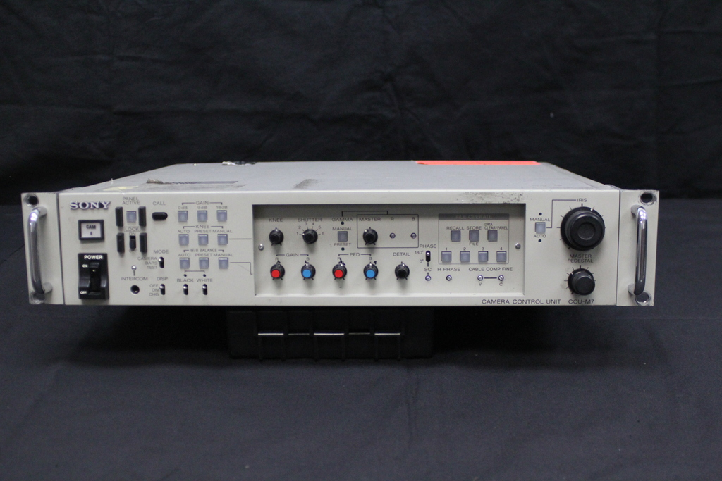

Plate 6: camera control unit

1. **Un-interrupted Power Supply**

Uninterruptible power supply (UPS).An uninterruptible power supply (UPS) is a device that allows a device to keep running for at least a short time when the power source is lost. It also provides protection from power surges.

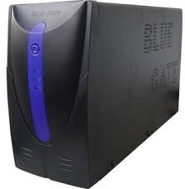

Plate 7: Un-interruptible Power Supply

1. **CPU/Monitor**

The central processing unit (CPU) is used to displayprogramme that has been stored and store a multiple programmes for retrieval.



Plate 8: CPU/Monitor

I also learnt about the master control room connection in which shows how the devices are connected with all the inputs from the room and the output sent to the transmitter and star times.

MIC 1

STAR TIME

MIC 2

VISION MIXER

AUDIO MIXER

HDD

CPU

TVRO

CAM 1

CAM 2

TRANSMITTER

DISTRIBUTIONAL AMPLIFIER

**Output**

Input

Fig 1: Master control

Input

Where

MIC 1 > Microphone 1

MIC 2> Microphone 2

HDD > Hard Disk Drive

CPU > Central Processing Unit

TVRO > Television Receive Only

CAM 1 > Camera 1

CAM 2 > Camera 2

Audio mixer receive audio signal only

Vision mixer receive video signal only.

Distributional amplifier receives single signal and distributes the same signal to multiple outputs.

Transmitter received and send signal.Star times also received signal.

**3.2.2 Transmitter Room:** Thisis a place where audio and video signals wherereceived from control room. A transmitter (or radio transmitter) is an electronic device which produces radio waves with the help of an antenna. In the transmitter room, I was introduced to equipment attached to it, like air condition and blower.

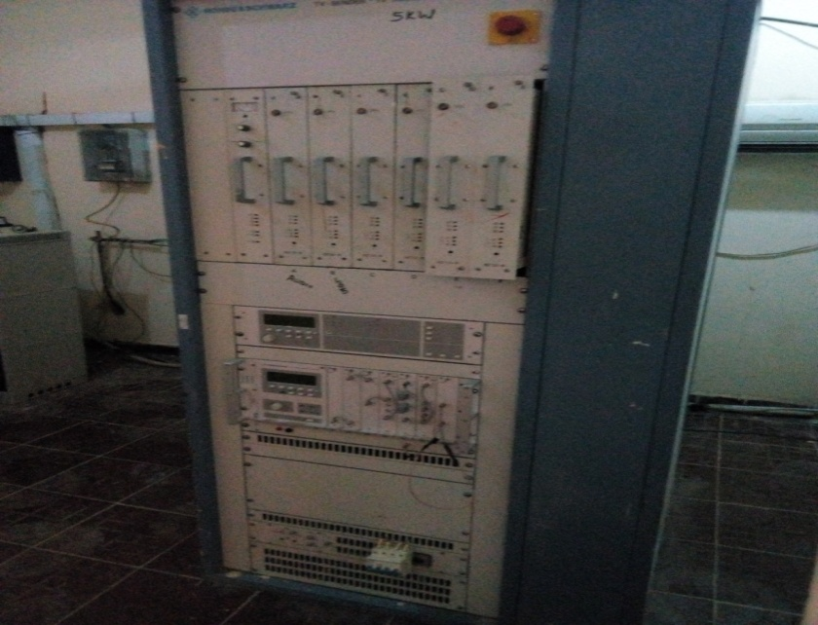

Plate 9: Transmitter

**Components of a transmitter:**

1. Exciters
2. Modulator
3. Oscillator
4. Combiners
5. Filters
6. Power supply unit
7. Exciter: comprises of modulator and oscillator: the electronic oscillator that generates the carrier signal for a transmitter
8. Oscillator: it generate radio frequency signal which is usually sine wave of constant amplitude known as carrier wave.

iii- Modulator:- it an electronic device that adds the confirmation to be transmitted to the carrier wave) can be expressed as

)…………………(3.1)

where;

(t) is the voltage of the signal as a function of time, V is the amplitude of the signal.

W = 2ΠfC,…………………………..……………(3.2)

Fc is the frequency of oscillation; ⱷ is the phase of the signal representing the starting point of the cycle

* + 1. **Editing Room:** Thisis a place in which television programme is prepared by selecting, rearranging or rejecting previous or unwanted programme using computer. Thus, the useful one is feed to the server for storage an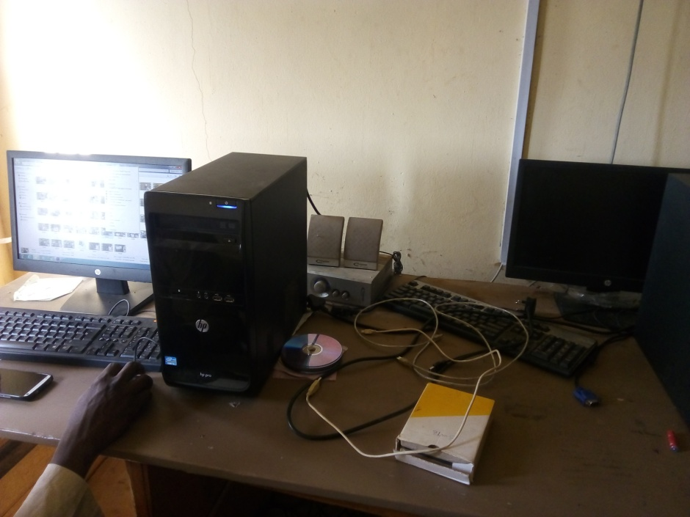d retrieval.

Plate 10: Editing Room

* + 1. **Studio Room:**Is a place where broadcast and live programmes take place with the aids of some components such as video camera, micr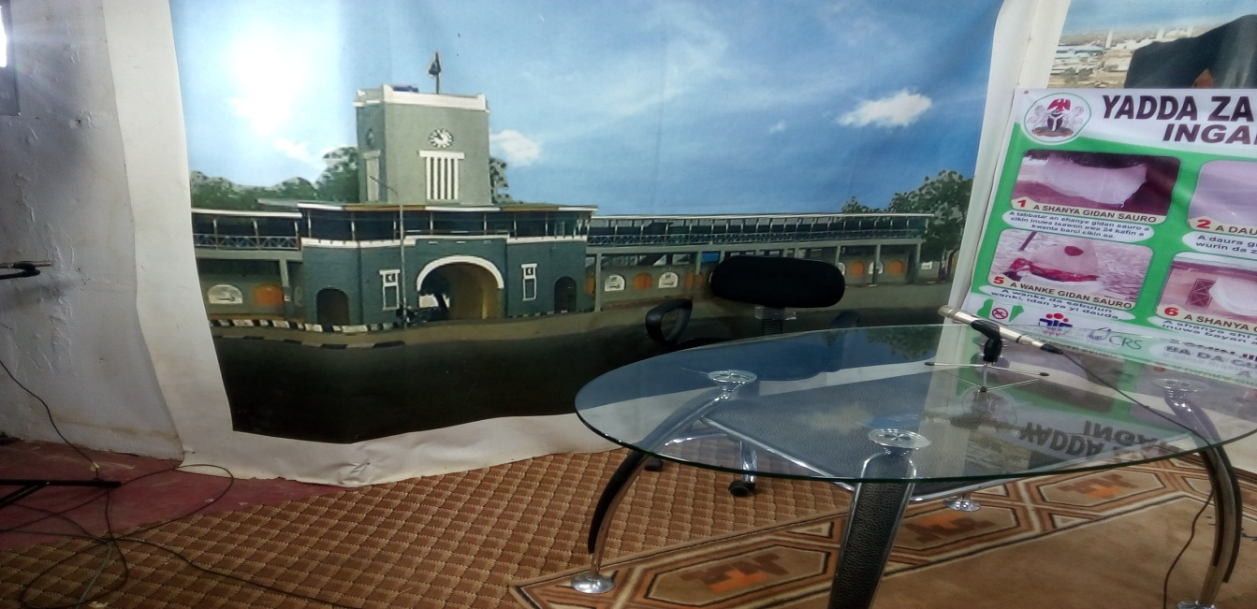ophones.

Plate 11: Studio Room

**3.2.5 Maintenance Section**

The role of the Maintenance section is to ensure smooth running of structures, equipment, machines, furniture and other facilities. Some activities during the training in this section include; repairing, servicing, inspecting/installation and testing of equipment and other electronic devices I was also exposed to measuring instruments and basic components of electronic devices such as multimeter, ammeter, voltmeter, transformer, resistor, capacitor, diode, transistor and integrated circuit.

1. Multimeter

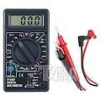A multimeter or a multitester is an electronic measuring instrument that combines several measurement functions in one unit. Multimeter may be analogue or digital.

Plate 12:digitalmultimeter

**(b)Resistor**

A resistor is a device offers an opposition to the flow of current. Resistor is measured with an instrument called Ohmmeter and its unit is Ohms.

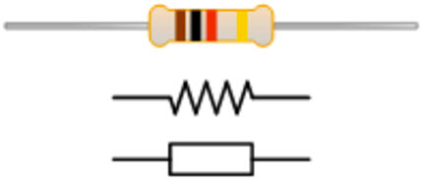

Plate 13: resistor

**© Capacitor**

A capacitor is a two terminal linear passive component that is made from 2 conductive plates with an insulator between them. The main function of a capacitor is that, it stores voltage once an electrical charge is forced onto its terminals from a power supply. It maintains the charge even when getting disconnected from the power supply.

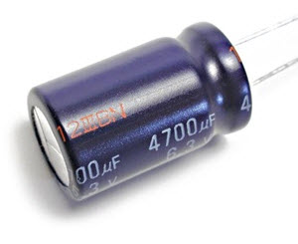

Plate 14: capacitor

1. **Diode**

A diode is a semiconductor device that allows current to pass or flow only in one direction. The most common function of a diode is to allow an electric current to pass in one direction called diode's forward direction while blocking the reverse direction.

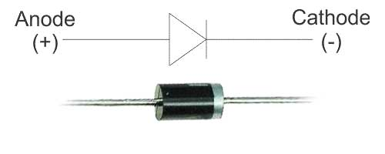

Plate 15: Diode

1. **Integrated Circuit(IC)**

IC is an electronic circuit on a small piece of semiconducting material, performing the same function as larger circuit of discrete components.

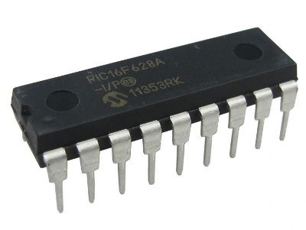

Plate 16 Integrated Circuit(IC)

**3.3.Application of physical theory**

Compared to the physical theories with what I have been taught in the class, I experience a lot of things in KTTV telecommunication network which include:

* + 1. **Application Of Field Effect Transistor in Transmission**

The field-effect transistor (FET) is a transistor that uses an electric field to control the electrical behavior of the device. FETs are also known as unipolar transistors since they involve single-carrier-type operation.Field effect transistors generally display very [high input impedance](https://en.wikipedia.org/wiki/High_impedance" \o "High impedance) at low frequencies. The [conductivity](https://en.wikipedia.org/wiki/Electrical_resistivity_and_conductivity" \o "Electrical resistivity and conductivity) between the drain and source terminals is controlled by an electric field in the device, which is generated by the voltage difference between the body and the gate of the device.

It is use as

* Mixer operation of frequency modulation and television receiver
* Voltage variable resistor (VVR) in operational amplifiers.

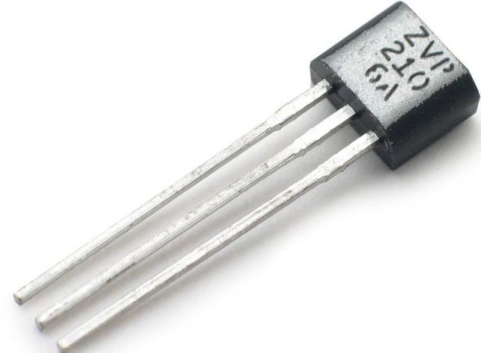

Plate 17:Field Effect Transistor

* + 1. **Application Of Integrated Circuit (Ic)**

Since the various component of an IC are located closed to each other in or on silicon wafer, the time delay of signal is reduce, moreover, because of short distance, the change of stray electrical pickup (called parasitic capacitance) is practically nil. Hence it is very suitable for small signal operation and high frequency operation. As a result, the response time or operating speed of the system is improved and hence IC is selected for transmission.Therefore, IC Increase response time and speed.

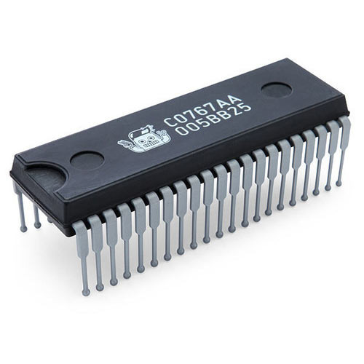

Plate 18: Integrated Circuit

**3.3.3 Application Of Amplifier In Transmission**

Amplification basically means increasing the amplitude of the signal without changing its time period or wavelength. So a standard audio-level signal is approximately 1V (peak to peak). An audio amplifier operates on a higher voltage, say 12V. The 1V signal is being used to manipulate the 12V supply to produce a larger signal up to 12V peak to peak which is then fed to the loud speakers. For much of the time that 12V supply is not being used to capacity.

Amplification is done because when the signal is transmitted over the communication channel and before it is received at the receiver, the signal generally suffer distortion and is witnessed by heavy noises coming from background, atmosphere, etc sources or say louder noises than the signal. These noises cause the information in the signal hard to get retrieved, the noisy signal passes through a filter at the receiver and then amplification is done. If signal is not amplified it shall be very weak to analyze or would have lost in those noises which have larger amplitude than the signal itself. Actually to save the signal from noises just amplification is not the key, there are many more things

**3.4Application of Physical theories, law and principles**

The physical theories, laws and principles that are applicable to the television stations which were examined include;

1. The microphone uses the principle of Faradays law of electromagnetic induction in the process of transforming sound into electronic (audio) signal .
2. The use of optical instruments in some studio devices such as the Camera and Telefronter.
3. The concept of measurement is useful in finding the continuity or faulty of a circuit components in.
4. Electromagnetic waves (radio waves) are needed for television broadcasting.
   1. **Limitation & Challenges**

Limitations

The limitation encountered during the SIWES include

* Restriction of swet student to operate of some machines /equipment

The challengesencountered during my SIWES are:

* Distance of KTTVKatsina from my town Dutsin-ma.
* Financial problems due to lack of funding.

**4.0 SUMMARY,CONCLUSION AND RECOMMENDATION.**

**4.1 Summary**

This SIWES report presents the experience garnered during mysix(6) months of industrial training undertaken at KTTVKatsina.My training was on the Engineering department that mostly combined the control room, transmitter room, Generator room and studio room.

During this period, I acquired practical knowledge on how to start generator, operate the transmitter, operates other devices like audio mixer, vision mixer, CCU and I also participated in repairing transmitter and replacing power pack. This report discusses the technical skills gained during the training period and justified the relevance of the scheme in equipping students with needed technical competence to thrive in the real world.

**4.2 Conclusion**

My six(6)months industrial attachment at KTTVkatsinawas a huge success and a great time of acquisition of knowledge and skills. Through my training I was able to appreciate my chosen course of study even more, because I had the opportunity to blend the theoretical knowledge acquired from school with the practical hands-on application of knowledge gained here to perform very important tasks that contributed in a way to my productivity in the company.

My training here has given me a broader view to the importance and relevance of the theory of physics thought in class, as I now look forward to impacting it positively after graduation. I have also been able to improve my communication and presentation skills and thereby developed good relationship with my fellow colleagues at work. I have also been able to appreciate the connection between my course of study and other disciplines in producing a successful result.

**4.3 Recommendation**

I would like to recommend that the B.Sc Physics curriculum in the Federal UniversityDutsinma to be adjusted such that would provide going on industrial attachments for a at least four different organization as opposed to 1 or 2 making the program to occur twice throughout the degree program.

Allowances should be paid to students during their programme just like NYSC and not after. This would help them a great deal to handle some financial problems during their training course.

**REFERENCES**

Adetona, Z.A, Koledoyet. O, Alebiosu M. I, (2013).Television Broadcasting Transmission in Nigeria : Application of Technical Data for Re-planning. Journal of Electrical and Electronics Engineering Vol.3 No.6 2013.

Akerejola, O. (2008). Information and guidelines for Student Industrial Work experience scheme. <http://www.itf-nigeria.org/docs/SIWES-op-guide>pdf.

Anas, G, (2013).A SIWES Report submitted to the Department of Physics, Ummaru Musa Yar’adua University.

Chijoke, F. U, Jonas, U.E. (2010).Challenges of Student Industrial Work Experience Scheme in Library and Information Science in the Enviroment.

Erickson, R. “Lecture 20.The Transistor as a Switching Device: Power Electronics ECE579 CourseNotes, Fall 1987, pg. 20-4 through 20-16.

Eze, N. M. (1998). Industrial Work Experience: A medium for Actualizing Vision 2010 through Home Economic Education. Journal of Women in College of Education 2:154 – 160.

Grob, B. and Herdon, C. E. (1999).“Basic Television and Video Systems”.6th Edition McGraw-Hill Book Co.

SIWES.(2008). Retrieved January 2015, from ITF: http://odich.com/itfnig/siwes.php

url: <http://www.allaboutelectronics.com/frequencymodulation> Retrieved 7 December, 2019

url: <http://www.itf.gov.ng> Retrieved 9 October,2019.

url: [http://www.nouedu.net/directorates/it-siwes Retrieved 5](http://www.nouedu.net/directorates/it-siwes%20%20Retrieved%205)th December , 2019.

url: <http://www.yabatech.edu.ng/unitinfo.SIWES.Retrieved>7 December , 2019

[Video/Audio Switches"](http://www.monoprice.com/products/department.asp?c_id=101).Monoprice.Retrieved 27 August 2013..

[Western Digital Settles Hard-Drive Capacity Lawsuit, Associated Press June 28, 2006"](http://www.foxnews.com/story/0,2933,201269,00.html). Fox News. March 22, 2001. Retrieved April 26, 2012